**Assignment-Semiconductor Diode**

**CO-1 and CO-2**

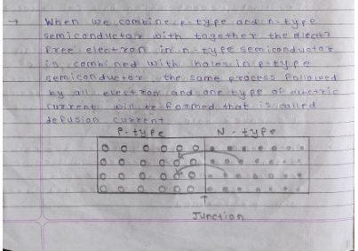Q-1 What happens when we combine P-type material and N-type material? Briefly explain with necessary diagram.

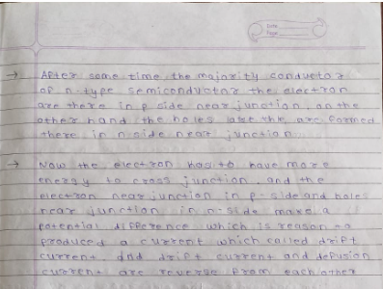

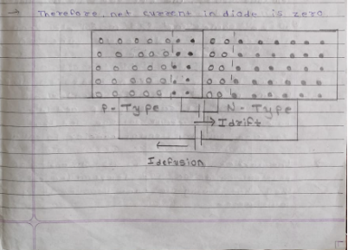

Q-2 What do you understand by the term forward bias of PN junction diode and reverse bias of PN junction diode? What is the effect of such bias on depletion region in both cases.



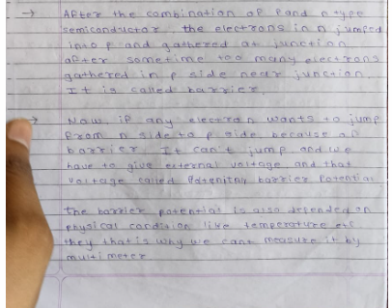

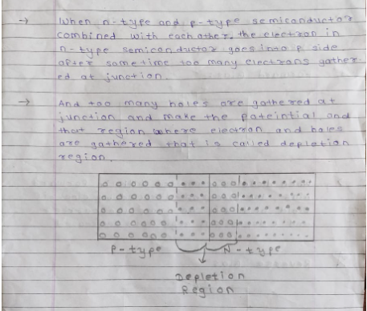

Q-3 Define the term reverse saturation current of PN junction diode.

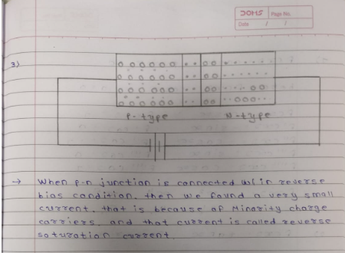

Q-4 What is reverse recovery time of a diode? What is its importance?

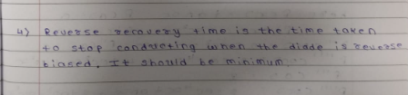

Q-5 What is the meaning of following diode specifications?

1.VF 2.IF 3.IR 4.PIV 5.PDmax

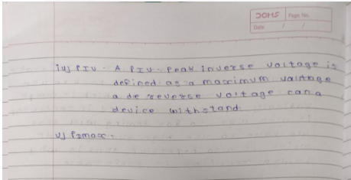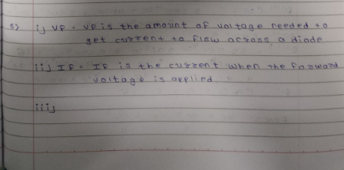

Q-6 What is limitations of Zener diode as a voltage regulator when we need to provide morecurrent to load connected across Zener diode?

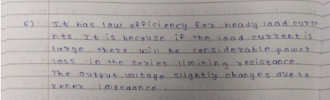

Q-7 Where can we find the applications of clipper circuits and clamper circuits?

Q-8 What is the importance of resistor connected in series with LED? What can happen if resistance is very less? What will happen if resistance is very high?

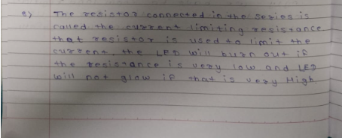

Q-9 It is possible to get full wave rectification with both center tapped and bridge rectifier. Out of these two which will you prefer? Why?

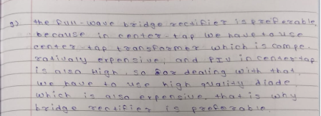

Q-10 What is the meaning of line regulation and load regulation? Why should we know it?

